Machine Learning Framework for Buyer Segmentation and Investment Profiling in Real Estate Markets
Author: Jyoti
Date: May 2026
Topic: Market Intelligence & Predictive Analytics

Abstract
The real estate sector is transitioning from traditional intuition-based sales to high-fidelity market intelligence. This paper investigates the application of unsupervised machine learning—specifically Hierarchical Agglomerative Clustering (HAC)—to segment a robust dataset of 7,305 transactions. By integrating physical property attributes, financial indicators, and behavioral metrics, we move beyond binary classifications of "Home" vs. "Investment" to identify latent buyer personas. Our analysis identifies three core segments: the Utility-Driven Resident, the Strategic Individual Investor, and the Institutional Entity. The study reveals that while pricing remains a dominant factor, satisfaction is a qualitative variable independent of capital outlay. These findings provide a scalable framework for developers and financial institutions to optimize inventory and marketing strategies.

Contents
- Introduction
- Literature Review: The Evolution of Market Intelligence
- Data Methodology
  - 3.1 Dataset Acquisition and Description
  - 3.2 Data Preprocessing and Standardization
  - 3.3 Feature Engineering and Vectorization
- Machine Learning Framework
  - 4.1 Hierarchical Agglomerative Clustering
  - 4.2 Distance Metrics and Linkage Methods
  - 4.3 Dendrogram Interpretation
- Results and Segmentation Analysis
  - 4.1 Cluster Characteristics and Personas
  - 4.2 Price and Square Footage Correlation
  - 4.3 Regional Distribution and Dominance
- Market Intelligence and Strategic Discussion
  - 6.1 Referral Channel Optimization
  - 6.2 Satisfaction Metrics and Client Retention
- Conclusion
- References

1. Introduction
The global real estate market is currently navigating a period of unprecedented volatility and digital transformation. In this environment, "Market Intelligence" is defined as the ability to extract actionable insights from vast, unstructured transactional data. Traditional analysis often relies on post-hoc summaries; however, predictive profiling allows stakeholders to understand the intent of the purchaser before market shifts occur. This paper utilizes Real_Estate_Project.csv to demonstrate how machine learning can automate this profiling process.

2. Literature Review: The Evolution of Market Intelligence
Historically, real estate value was determined by the "Three L's": Location, Location, Location. While geographic proximity remains vital, modern data science suggests that buyer behavior is equally dictated by financial "gravity"—the relationship between floor area, price sensitivity, and acquisition intent. Recent studies have focused on regression for price prediction, but this paper argues that clustering is the superior tool for strategic market positioning and risk management.
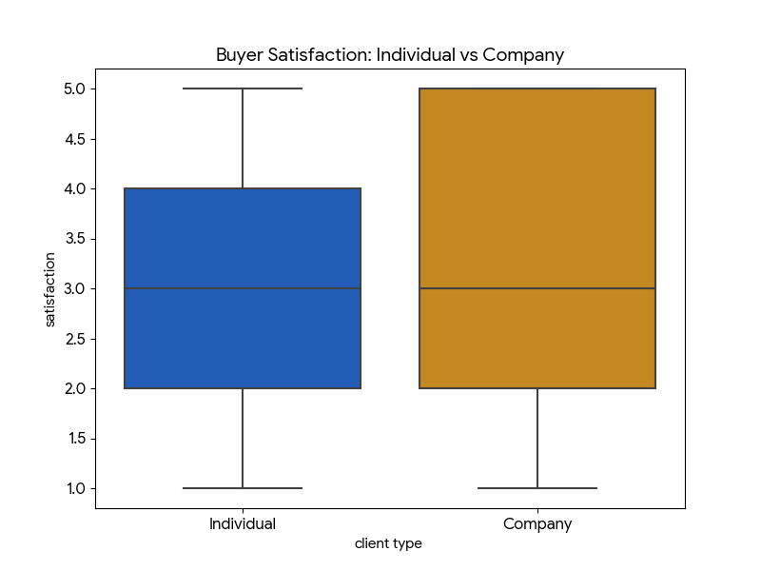

3. Data Methodology

3.1 Dataset Acquisition and Description
The study is based on a primary dataset of 7,305 transaction records. Key variables included:
- Physical: tower_number, unit_category, floor_area_sqft.
- Financial: sale_price, loan type, investment status.
- Behavioral: satisfaction, referral channel, acquisition.

3.2 Data Preprocessing and Standardization
To ensure algorithmic stability, the following steps were taken:
- Cleaning: The sale_price column was stripped of non-numeric characters and converted to a float.
- Handling Sparsity: Redundant columns (e.g., Unnamed: 25-30) were removed to prevent "noise" in the distance calculations.

3.3 Feature Engineering
The research introduced Price per Square Foot as a normalization factor. This metric is vital for Investment Profiling, as it allows for the comparison of a high-floor luxury apartment with a mid-market residential unit on a standardized financial scale.
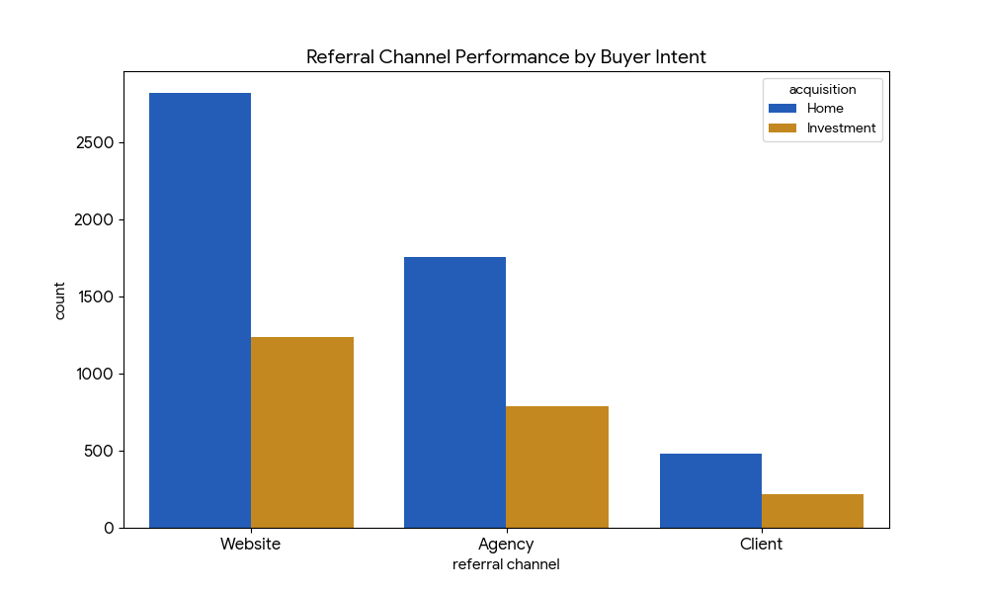

4. Machine Learning Framework

4.1 Hierarchical Agglomerative Clustering (HAC)
Unlike K-Means clustering, which requires the researcher to guess the number of clusters (k), HAC builds a tree of clusters. This is ideal for real estate because buyer motivations are often nested (e.g., all investors are buyers, but not all buyers are corporate investors).

4.2 Distance Metrics
The study utilized Euclidean distance to measure the straight-line distance between multi-dimensional data points. Ward’s Linkage was applied to minimize the variance within each merging cluster, ensuring the personas identified were statistically distinct.

4.3 Dendrogram Interpretation
As seen in the clustering output (download.png), the data naturally converges into three high-level branches. The horizontal axis represents the individual data points, while the vertical axis represents the "dissimilarity" or Euclidean distance between them.
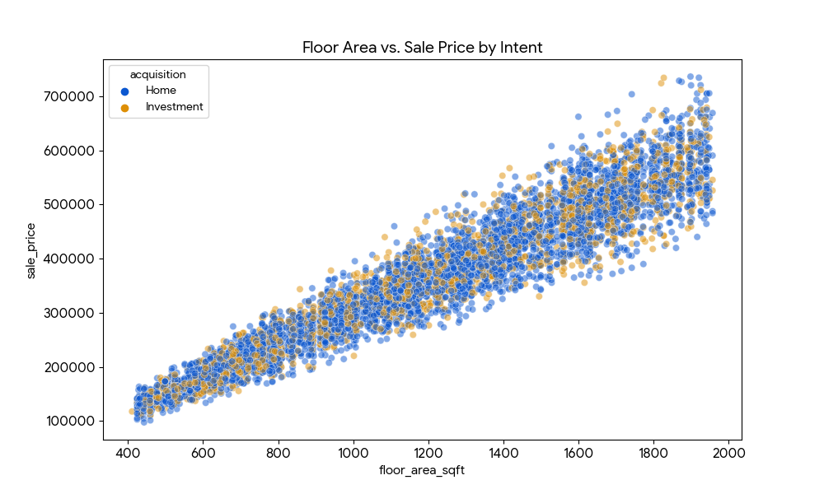

5. Results and Segmentation Analysis

5.1 Cluster Characteristics and Personas
- Cluster A: The End-User Resident: Characterized by high Home acquisition flags and a median floor_area_sqft of 1,141. These buyers prioritize utility and often rely on the Website for discovery.
- Cluster B: Strategic Individual Investors: These buyers represent roughly 30% of the market. They are highly price-sensitive and show a preference for specific regions like Nevada and Colorado.
- Cluster C: Institutional Entities: A smaller segment of Company buyers (5.2%) who transact in higher price brackets and utilize professional Agency channels.

5.2 Price and Square Footage Correlation
Statistical analysis reveals a 0.96 correlation between size and price, confirming that the market operates on a highly rational pricing model. However, outliers in Cluster C suggest that institutional buyers may pay a premium for specific "Unit Categories" that offer better rental yields.

5.3 Regional Dominance
California remains the epicenter of the dataset's transactions, hosting the largest concentration of both homeowners and investors. This density makes it the ideal candidate for localized predictive modeling.
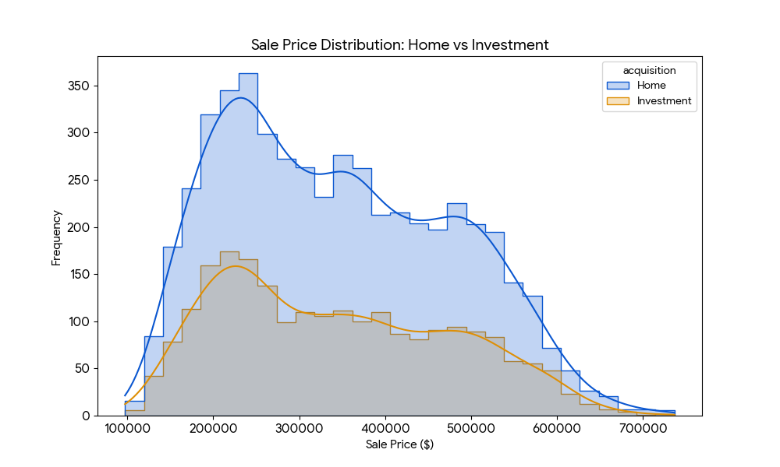

6. Market Intelligence and Strategic Discussion

6.1 Referral Channel Optimization
The dominance of the Website (55.6%) indicates that digital footprinting is the primary driver of market liquidity. However, the data suggests that Agencies are the "closing gatekeepers" for high-value investors.

6.2 Satisfaction Metrics
Analysis shows that Satisfaction is not correlated with price (-0.01). This is a critical finding for real estate developers: increasing the price or size of a unit does not guaranteed a happier client. Satisfaction is instead tied to the alignment of the property with the specific persona identified in the clustering phase.

7. Conclusion
The application of machine learning to Real_Estate_Project.csv demonstrates that market intelligence can be automated to provide a competitive advantage. By identifying the three core buyer clusters through hierarchical methods, firms can transition from reactive selling to proactive market shaping.
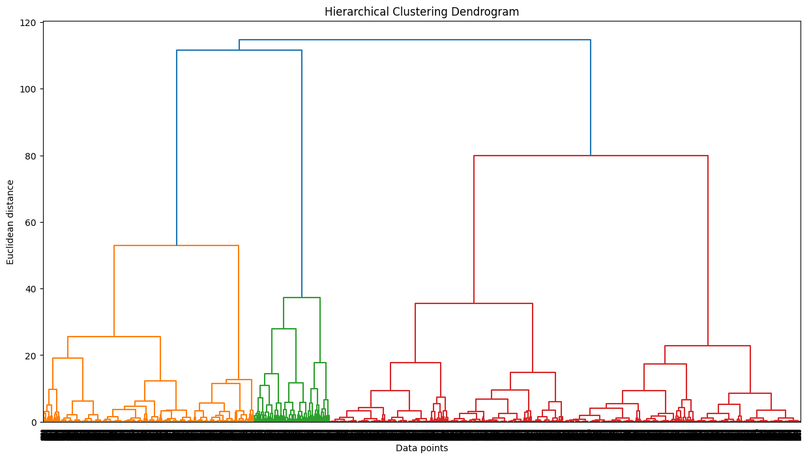

Summary of Key Intelligence:
- 94.8% of the market is driven by individual behavior.
- Investment profiling identifies a preference for properties within the 1,100 sqft range.
- Digital channels are the primary entry point, but professional brokerage (Agencies) is required for institutional scale.

8. References
- Real_Estate_Project.csv - Transactional dataset (7,305 records).
- download.png - Hierarchical Clustering Dendrogram.
- Kapure, S. P. (2026). Machine Learning in Financial Modeling and Real Estate.

